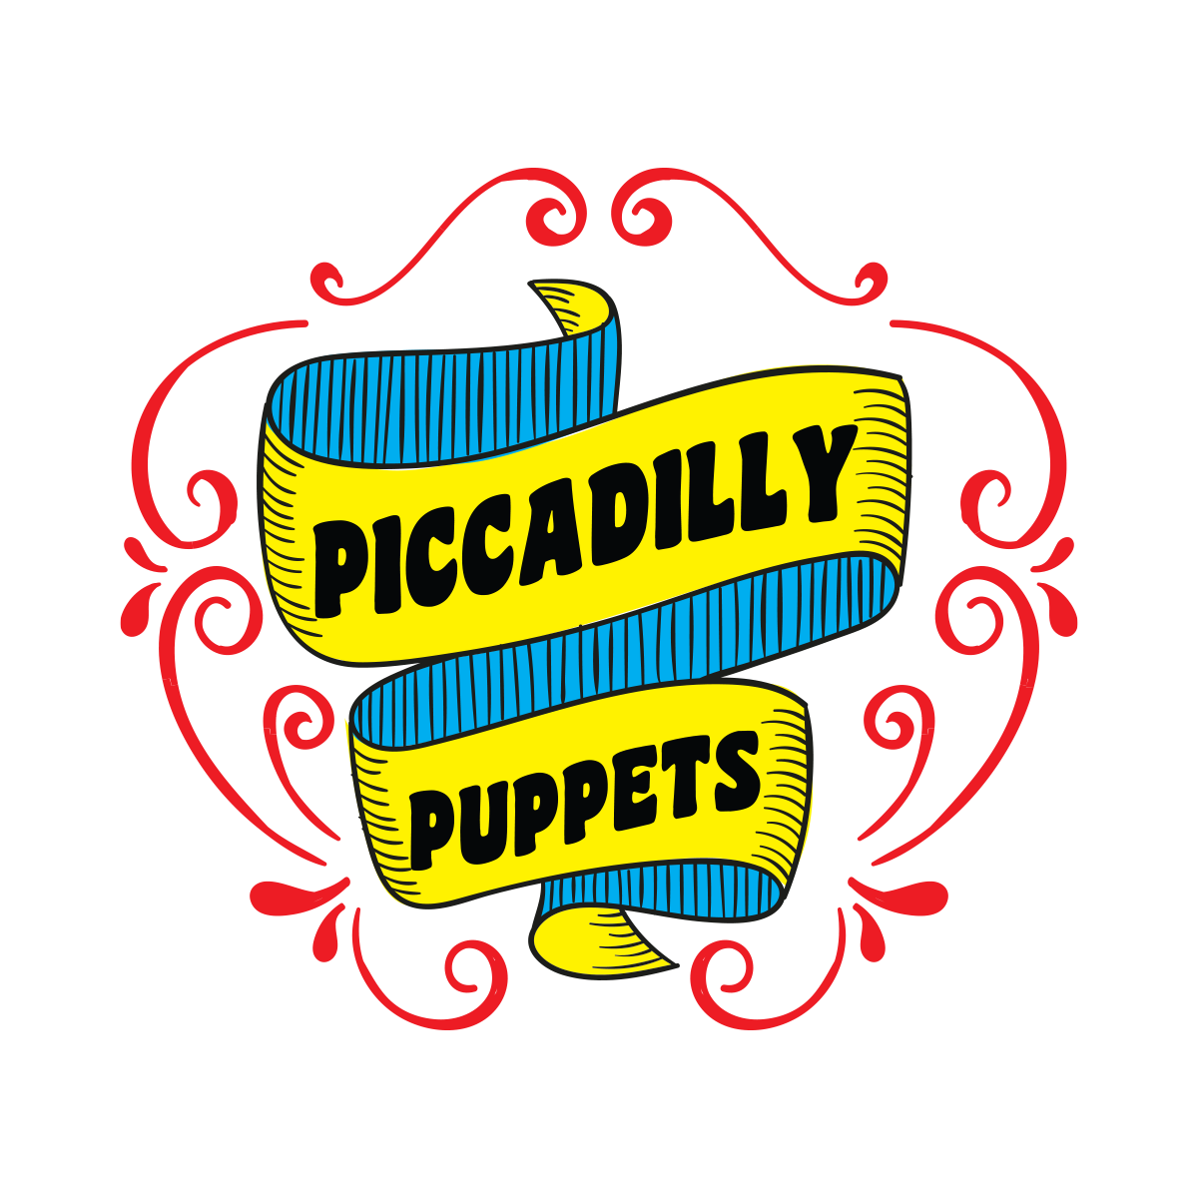
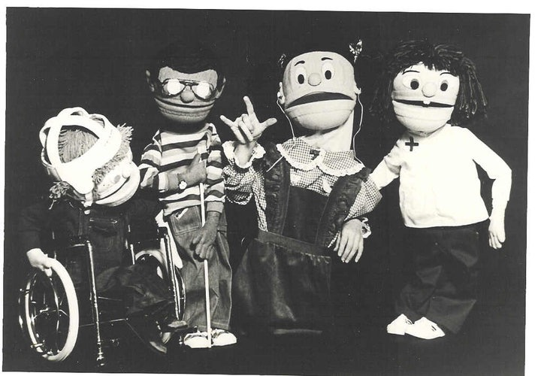

HISTORY

Piccadilly Puppets has been entertaining and educating students for for more than four decades. Our performers are professional puppeteers who also have extensive experience working with children. We use a variety of puppetry styles and offer a varied repertoire of programs that relate to curriculum.

Awarded the UNIMA Citation for Excellence in the Art of Puppetry
- Formerly on the Artist Roster of Arts For Learning

Duis Montes, Tellus Lobortis
In sodales libero suspendisse mauris quam etiam erat.

Duis Montes Tellus Lobortis
Varius natoque ac turpis est leo primis elementum est.

learning objectives
- Students will be able to define various disabilities.
- Students will recognize the needs of some special populations, and will discover ways to solve potential problems kids with disabilities might encounter.
- Students without disabilities will learn to relate to those that have disabilities by learning that, although we may have differences, we are very much the same in a lot of ways, and we can be friends.
Lorem Ipsum January 11, 2016
Piccadilly Puppets Classroom Guide
Kids on the Block
Kids on the Block is a program utilizing puppets to sensitize children to the needs of special populations with disabilities. The program features puppets with special challenges – cerebral palsy, hearing impairment, visual impairment and Down Syndrome. There is scripted dialogue among the puppet characters, as well as dialogue between the puppets and the children in the audience.
Discuss various disabilities with the students and see how they feel about that disability and how it might limit their activities. (Ex. Can someone in a wheelchair play soccer?) How does a deaf person communicate? What difficulties would a deaf person face in your classroom?
Place a blindfold over a child’s eyes and see how much difficulty he or she has in moving around the classroom. The children may be surprised at how much they are able to do without sight. How does a guide dog help a blind person? (guiding and protecting)
Ask if any of the children have friends or relatives with disabilities.
Discuss what types of jobs they feel disabled people can do.
Do the children feel uncomfortable around a disabled person? Why?

Pre-Show Activities
Discuss how their feelings about disabilities are different now than they were before seeing Kids on the Block. Do they think Mark and Renaldo could go on a camping trip with them? What challenges might arise for Mark and Renaldo on a camping trip?
Discuss the ADA – Americans with Disabilities Act. All public buildings must be accessible to disabled people. Think about changes that had to be made to buildings – wider bathroom doors, ramps, etc.
Have the children go around your school building and identify problems that might be encountered by a student in a wheelchair. Can he eat at the tables in your lunchroom? What types of special accommodations might be needed?
Extend the Learning: Post-Show Activities
- Cerebral Palsy – a nonprogressive disorder of movement or posture beginning in childhood due to a malfunction or damage to the brain. In this show Mark does not have full use of his legs; the message from his brain to his legs is “short-circuited.”
- Quadriplegic – partial of total paralysis of all four limbs.
- Hearing Impairment – can be partial or total loss of hearing due to genetic causes, trauma, accident, or disease. Two main types of hearing impairment are decibel loss (all sounds would be softer), and frequency loss (loss of higher pitches is most common).
- Total Communication – combination of sign, speech, and lip reading to cope with hearing loss. There are 38 million people in the U.S. with significant hearing loss.
- Braille – a system of “touch reading.” A Braille writer has 6 keys which are combined in different ways to form words.
- Down Syndrome - a genetic disorder caused by the presence of all or part of a third copy of chromosome 21. Down syndrome is the most common chromosome abnormality in humans. It is typically associated with physical growth delays, a particular set of facial characteristics and a severe degree of intellectual disability.

Vocabulary
Additional Resources
Books
Kids Explore the Gifts of Children With Special Needs – Westridge Young Writers Workshop.
Hearts of Gold: A Celebration of Special Olympics and its Heroes – Sheila Dinn.
Extraordinary People with Disabilities – Deborah Kent, Kathryn A. Quinlan
(a collection of short biographies).
Let’s Talk About it: Extraordinary Friends – Fred Rogers.
Talking About Disability – Jillian Powell.
A list of more children’s books about disabilities can be found on the Teacher Vision website:
http://www.teachervision.fen.com/learning-disabilities/reading/5316.html

Internet
National Dissemination Center for Children with Disabilities - www.nichcy.org
Learning Disabilities Online - www.ldonline.org
Seeing Disabilities from a Different Perspective - library.thinkquest.org/5852 (Note: there is no www before this page. If you can’t find it, try going to http://www.thinkquest.org/pls/html/think.library and searching for “disabilities”).
A search for AMERICAN SIGN LANGUAGE will bring up many sites
International Paralympic Committee - www.paralympic.org/

